**A Major Qualifying Report submitted to the faculty of**

**BML MUNJAL UNIVERSITY**



**“Partially meets the requirements of the Degree Bachelor of Technology in Computer Science and Engineering”**

**I**

**By:**

**Hardik Pandey(220458)**

**Academic Year – (2022 – 23)**

**Connecting the dots between higher education and unemployabliity in India**

**COURSE –** MATHEMATICS FOR ENGINEERING- II

**COURSE FACULTY –** DR. RANJIB BANERJEE

**Acknowledgment**

We would like to express our sincere gratitude to our teacher, Dr. Ranjib Banerjee, for his invaluable guidance throughout the project. His unwavering support and advice were instrumental in resolving our doubts and challenges, and his motivation was a driving force behind our successful completion of the project.

We would also like to extend our heartfelt appreciation to all the members of our group who worked tirelessly and gave their best to ensure that our project was of the highest quality. Their dedication and hard work were key to our success.

Finally, we would like to express our gratitude to all those who provided their support and encouragement, both during the project and in our personal lives. Your unwavering support was a great source of inspiration, and we could not have completed this project without you.

Abstract

The relationship between higher education and unemployment has garnered significant attention in the context of India, a country experiencing rapid growth and development. This report aims to explore and understand the dynamics between higher education enrollment and unemployment trends in India. The study examines the enrollment patterns in higher education institutions and analyzes unemployment rates over time to identify potential correlations and factors contributing to unemployment. The research utilizes a quantitative research design, drawing on data from various sources such as government reports, academic publications, and surveys. Data analysis techniques including statistical analysis and visualization are employed to examine the relationship between higher education and unemployment, considering variables such as education levels, skill mismatch, and industry demands. The findings shed light on the challenges and opportunities in aligning higher education with the needs of the job market, as well as identifying potential policy interventions to address unemployment. The study contributes to the existing body of knowledge by providing insights into the complex relationship between higher education and unemployment in India, and offers recommendations to bridge the gap between education and employment, thus contributing to sustainable and inclusive growth.

Furthermore, the report examines the implications of the findings for policymakers, educational institutions, and stakeholders involved in shaping educational policies and programs. It highlights the need for greater emphasis on skill development initiatives, industry-academia collaboration, and career guidance programs to enhance the employability of higher education graduates. The study also emphasizes the importance of aligning educational curricula with the evolving needs of the job market to address the issue of skill mismatch. By offering a comprehensive analysis of the relationship between higher education and unemployment, this report aims to contribute to evidence-based decision-making and foster a more effective and efficient higher education system in India, ultimately promoting greater economic productivity and reducing unemployment rates.

Introduction

Higher education plays a crucial role in shaping the future of individuals and societies by equipping them with knowledge, skills, and competencies necessary for personal growth and economic development. In India, a country with a vast and diverse population, the relationship between higher education and unemployment has been a topic of significant concern. As the nation strives to achieve sustainable and inclusive growth, understanding the dynamics between these two factors becomes essential.

**1.1 Background**

India has witnessed a substantial growth in its higher education sector in recent decades. The country boasts a large number of universities, colleges, and institutes offering a wide range of academic programs and professional courses. This expansion of higher education has been driven by factors such as increasing demand for skilled professionals, economic liberalization, and a growing awareness of the importance of education.

However, despite the expansion of the higher education system, the issue of unemployment continues to persist, especially among the educated youth. Many graduates find themselves struggling to secure suitable employment opportunities, leading to concerns about the effectiveness of higher education in preparing individuals for the job market. This raises questions about the relevance of education, the skill sets acquired through higher education, and the factors contributing to unemployment in the country.

**1.2 Problem Statement**

The primary focus of this report is to explore the connection between higher education and unemployment in India. By examining enrollment trends in higher education institutions and analyzing unemployment rates over time, we aim to identify the patterns, dynamics, and potential relationships between these two factors. Additionally, we will investigate the factors that may influence employment prospects for higher education graduates, including the role of skills, industry-academia collaboration, and government initiatives.

**1.3 Objectives**

The specific objectives of this report are as follows:

1. To analyze the enrollment trends in higher education institutions in India over a specific period.
2. To examine the unemployment trends in India and identify any significant variations or patterns.
3. To explore the relationship between higher education and unemployment, considering factors such as education levels, skill mismatch, and industry demands.
4. To provide insights and recommendations that can contribute to bridging the gap between higher education and employment, with the aim of reducing unemployment rates in India.

By achieving these objectives, we aim to contribute to the existing body of knowledge on the subject and provide valuable insights for policymakers, educational institutions, and stakeholders involved in the development of effective strategies to address unemployment issues in India.

Methodology

The methodology adopted for this report involves a rigorous and comprehensive analysis of Enrollment and Employability of students from 2012 to 2021. To ensure the reliability and representativeness of the data used in the analysis, we collected data from various sources, including secondary research reports, news articles, and public databases such as Kaggle. We carefully pre-processed the data obtained from Kaggle to ensure its accuracy and completeness. We removed any missing values and manually added information that was not provided in the database. This helped us to obtain reliable and accurate data for our analysis.

The report focuses on four key parameters, namely, enrollment from different stream, employability, employability from different domain, and effect of higher education on employability, to analyze the growth of startups in India. For each of these parameters, we collected data on the enrollment in ug courses, pg courses, the growth in different domains, effect of different courses in employability. To analyze the data and draw meaningful insights, we used R programming language, which is a powerful tool for statistical analysis and data visualization. We conducted in-depth analysis and graphical comparisons on the basis of all the above parameters, using various data visualization techniques, such as bar charts and line graphs.

The report is generated using R Markdown, which is an open-source tool for creating dynamic documents that combine text, code, and graphical output. This ensures that our analysis is adequately represented in the report, and readers can easily reproduce our findings. Overall, the methodology adopted for this report is robust, and reliable, and provides a comprehensive understanding of the Indian startup ecosystem and its growth from 2015 to 2021.

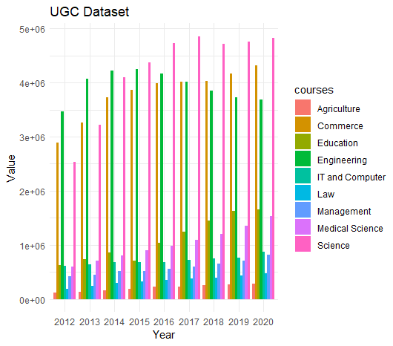

ugc<-read_excel("D:\\Maths SEM 2 report\\Enrollment\\ug courses.xlsx")

ugc

ugc_long <- tidyr::pivot_longer(ugc, -courses, names_to = "Year", values_to = "Value")

ggplot(ugc_long, aes(x = Year, y = Value, fill = courses)) +

geom_bar(stat = "identity", position = "dodge") +

labs(x = "Year", y = "Value", title = "UGC Dataset") +

theme_minimal()

As we can see in the bar graph, enrollment of students in ug courses is increasing in Science, Medical science is increasing each year. Courses like Medical Science, Commerce and Engineering sees the most enrollment every year.

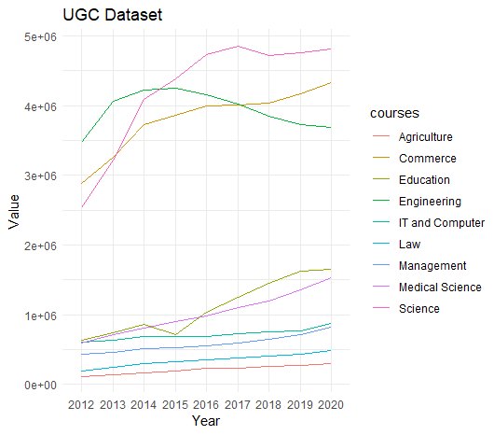

pgc <- read_excel("D:\\Maths SEM 2 report\\Enrollment\\Ug courses.xlsx")

pgc_long <- tidyr::pivot_longer(pgc, -courses, names_to = "Year", values_to = "Value")

ggplot(pgc_long, aes(x = Year, y = Value, group = courses, color = courses)) +

geom_line() +

labs(x = "Year", y = "Value", title = "UGC Dataset") +

theme_minimal()

There was peak enrollment in engineering sector in 2014-2015 but a decrease in next years. Growth of enrollment in agriculture, management, law, it and computer is close to straight line. Commerce and medical science shows rapid growth each year.

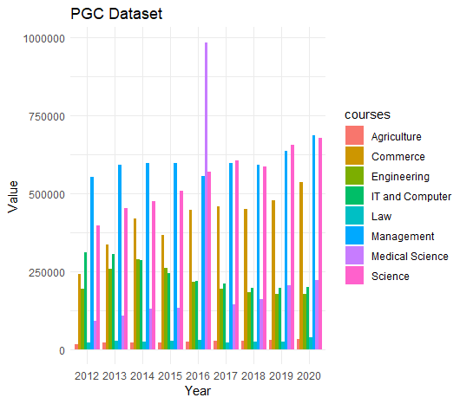

ugc<-read_excel("D:\\Maths SEM 2 report\\Enrollment\\pg courses.xlsx")

ugc

ugc_long <- tidyr::pivot_longer(ugc, -courses, names_to = "Year", values_to = "Value")

ggplot(ugc_long, aes(x = Year, y = Value, fill = courses)) +

geom_bar(stat = "identity", position = "dodge") +

labs(x = "Year", y = "Value", title = "PGC Dataset") +

theme_minimal()

As usual, Pg courses of management and medical science sees the most no of enrollment in the education sector. Engineering and law compared to its ug courses sees a less no of enrollment. As in 2016, there was implementation of NEET, which is a common medical test for all India and it gave a boost in the medical science education sector in the year.

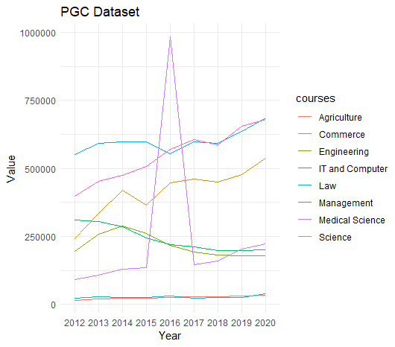3

pgc <- read_excel("D:\\Maths SEM 2 report\\Enrollment\\pg courses.xlsx")

pgc_long <- tidyr::pivot_longer(pgc, -courses, names_to = "Year", values_to = "Value")

ggplot(pgc_long, aes(x = Year, y = Value, group = courses, color = courses)) +

geom_line() +

labs(x = "Year", y = "Value", title = "PGC Dataset") +

theme_minimal()

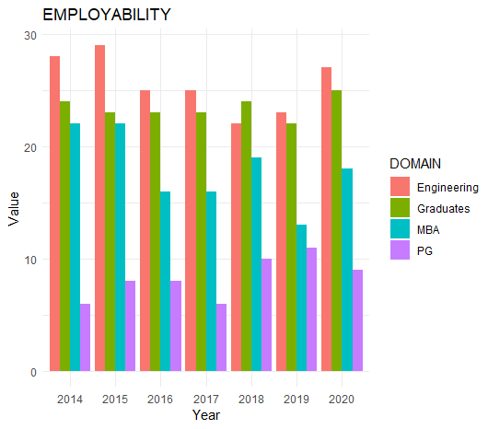

ugc<-read_excel("D:\\Maths SEM 2 report\\Employability\\Employablity.xlsx")

ugc

ugc_long <- tidyr::pivot_longer(ugc, -DOMAIN, names_to = "Year", values_to = "Value")

ggplot(ugc_long, aes(x = Year, y = Value, fill = DOMAIN)) +

geom_bar(stat = "identity", position = "dodge") +

labs(x = "Year", y = "Value", title = "EMPLOYABILITY") +

theme_minimal()

Engineering gives the most no of jobs which gives us the reason of most enrollments in the course. Same goes with MBA, it had the maximum no of enrollments in pg courses because of the percentage of jobs it provide.

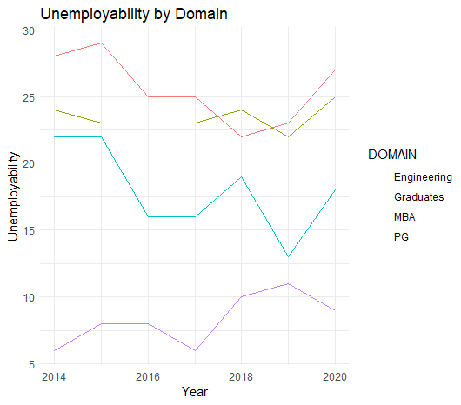

unemployability<-read_excel("D:\\Maths SEM 2 report\\Employability\\Employablity.xlsx")

data_long <- tidyr::pivot_longer(unemployability, -DOMAIN, names_to = "Year", values_to = "Value")

data_long$Year <- as.numeric(data_long$Year)

ggplot(data_long, aes(x = Year, y = Value, color = DOMAIN)) +

geom_line() +

labs(x = "Year", y = "Unemployability", title = "Unemployability by Domain") +

theme_minimal()

Conclusion

The findings of this study shed light on the complex relationship between higher education and unemployment in India. The analysis of enrollment trends in higher education institutions revealed a significant growth in student participation over the years, reflecting the increasing demand for higher education. However, the unemployment trends indicated persistent challenges in translating higher education credentials into suitable employment opportunities. Skill mismatch, lack of industry-relevant training, and regional disparities were identified as key factors contributing to the unemployment problem.

The study underscores the need for a multidimensional approach to address these challenges. Policy interventions should focus on strengthening the link between higher education and the job market by fostering greater industry-academia collaboration, promoting skill development programs, and integrating practical training opportunities within the curriculum. Additionally, career guidance and counseling services should be enhanced to help students make informed choices and align their education with market demands.

It is imperative for policymakers, educational institutions, and stakeholders to recognize the evolving nature of the job market and adapt educational frameworks accordingly. Emphasizing a holistic approach to education that combines academic knowledge with practical skills and industry exposure will help bridge the gap between higher education and employment. This requires a collaborative effort involving the government, educational institutions, industries, and society at large.

By aligning higher education with the demands of the job market, India can foster a skilled and employable workforce, paving the way for sustainable economic growth and reduced unemployment rates. The insights provided in this report contribute to evidence-based decision-making and serve as a valuable resource for policymakers and educational stakeholders in shaping effective strategies and policies.

In conclusion, connecting the dots between higher education and unemployment in India requires a comprehensive and dynamic approach that recognizes the changing dynamics of the job market and equips students with the necessary skills and competencies to thrive in a competitive employment landscape. By addressing the challenges identified in this study and implementing targeted interventions, India can unlock the full potential of its higher education system and pave the way for a prosperous and inclusive future.

References

<https://wheebox.com/assets/pdf/ISR_Report_2014.pdf>

<https://wheebox.com/assets/pdf/ISR_Report_2015.pdf>

<https://wheebox.com/assets/pdf/ISR_Report_2016.pdf>

<https://wheebox.com/assets/pdf/ISR_Report_2017.pdf>

<https://wheebox.com/assets/pdf/ISR_Report_2018.pdf>

<https://wheebox.com/assets/pdf/ISR_Report_2019.pdf>

<https://wheebox.com/assets/pdf/ISR_Report_2020.pdf>

<https://aishe.gov.in/aishe/viewDocument.action;jsessionid=88FD1CA52AFA9B32B2136DA9E4124E93.n3?documentId=194>

<https://aishe.gov.in/aishe/viewDocument.action;jsessionid=88FD1CA52AFA9B32B2136DA9E4124E93.n3?documentId=196>

<https://aishe.gov.in/aishe/viewDocument.action;jsessionid=88FD1CA52AFA9B32B2136DA9E4124E93.n3?documentId=206>

<https://aishe.gov.in/aishe/viewDocument.action;jsessionid=88FD1CA52AFA9B32B2136DA9E4124E93.n3?documentId=227>

<https://aishe.gov.in/aishe/viewDocument.action;jsessionid=88FD1CA52AFA9B32B2136DA9E4124E93.n3?documentId=239>

<https://aishe.gov.in/aishe/viewDocument.action;jsessionid=88FD1CA52AFA9B32B2136DA9E4124E93.n3?documentId=245>

<https://aishe.gov.in/aishe/viewDocument.action;jsessionid=88FD1CA52AFA9B32B2136DA9E4124E93.n3?documentId=262>

<https://aishe.gov.in/aishe/viewDocument.action;jsessionid=88FD1CA52AFA9B32B2136DA9E4124E93.n3?documentId=277>

<https://aishe.gov.in/aishe/viewDocument.action;jsessionid=88FD1CA52AFA9B32B2136DA9E4124E93.n3?documentId=322>